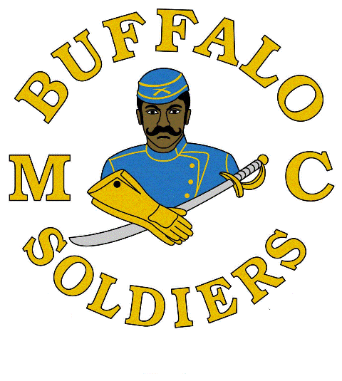
NATIONAL ASSOSICIATION BUFFALO SOLDIERS TROOPERS MOTORCYCLE CLUB, INC. - SOUTHWEST ILLINOIS 2024 SCHOLARSHIP ESSAY COMPETITION ANNOUNCEMENT AND APPLICATION

In 1993, the Buffalo Soldiers Motorcycle Club was founded in Chicago by Ken “Dream Maker” Thomas to socialize men and women who shared similar ideals and the common bond of motorcycling. The name was chosen to uphold and perpetuate the heroic legend of the original BUFFALO SOLDIERS and the legacy of excellence of the African American soldiers who followed.

Award: College scholarship range: $1000 - $3000.
Open to all high school seniors of the surrounding Illinois metro area in pursuit of a higher education. This scholarship can be used at any Vocational/Higher Educational Institution attended by the winner.

REQUIREMENTS FOR EACH APPLICANT: SAVE ALL PRODUCTS IN A FOLDER AND SHARE THE FOLDER
- Must be a U.S. citizen or permanent resident.
- ACT/SAT Scores
- Official High School Transcript (or equivalent if home schooled)
- Letter of recommendation on official letter head from a teacher, guidance counselor or school administrator.
- Letter of recommendation for community service or volunteerism.
- A letter of acceptance to an institution of higher learning
- Signed Release Form (enclosed)
- Parent’s signature if student is under 18 years old
- Prepare a letter of introduction; that states who you are, your accomplishments to date, family background, and the degree to which you are seeking, and financial need. Provide a brief summary on how you plan to use the scholarship if selected.
- Provide Student’s name, the complete name and address of the school and/or financial aid office where they will be attending school and student ID number. Checks will be mailed to the school via the student’s account.
- Complete all forms in its entirety. Attach additional pages if required.
- Incomplete packages will automatically be eliminated.
- Senior graduating the 2024 school year with a minimum un-weighted GPA of 2.5.
- Must submit completed application provided on next page(s) by deadline Friday, MARCH 29, 2024.
- Must submit an original, typed, double-spaced, 12 font, Times New Roman essay (500 words minimum) neither previously published nor secured by copyright on one of following topics below:

- What impact did the Buffalo Soldiers make in war and/or peacetime? Why is it necessary to pass this legacy on to future generations?

- Provide specific examples of how the Buffalo Soldiers accomplishments are still significant to modern day roadways, parks and mail.

- The Congressional Medal of Honor is presented to the recipient by the President of the United States in the name of Congress. Please provide a brief narrative regarding a Buffalo Soldier that received this honor and what can be learned from his life, efforts and commitment to duty.

NOTE: All documents must be saved in a folder and the folder shared/submitted no later than midnight, Friday, MARCH 29, 2024 in one of the following methods: U. S. Mail—BSMCSWIL, P.O. Box 95, O’Fallon, IL 62269 / email—in .doc / .pdf format to the following email address: swilscholarship@gmail.com

