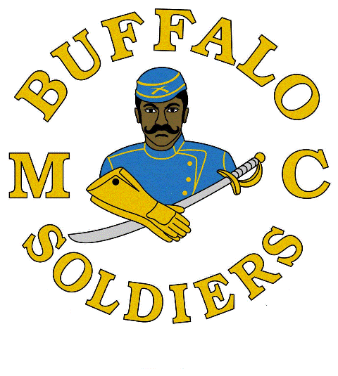

2024 Buffalo Soldiers Scholarship Competition Application
Deadline: Friday, MARCH 29, 2024
Do not attach a resume in lieu of completing this form. It will not be reviewed.
SAVE ALL PRODUCTS IN A FOLDER AND SHARE THE FOLDER

Contact Information:

First Name: |  | Last Name:
Address:
City: |  | State:
Zip Code: |  | Email:
Home Phone: |  | Cell Phone:
Date of Birth: |  | Gender:

Academic Information:
High School Name: |  | City / State
Graduation Date: |  | GPA:
Class Rank: |  | Class Size:
ACT Composite Score: |  | SAT Critical Reading Score:
SAT Math Score: |  | SAT Written Score:
Does Your school offer Honors, AP, or IB Programs, Dual Enrollment? Yes / No
Number of Honors Classes You Have Taken: | Number of AP Classes You Have Taken: | Number of IB Classes You Have Taken: | Number of Dual Enrollment Classes You Have Taken:

College Information (If you have not finalized your college choice, provide your first choice school.):
College Name: |  | City / State:
Institution Type: Certificate Four-Year Two-Year Vocational or Technical:
Degree Sought: Associates Bachelors Certificate
Major:
Anticipated Graduation Date:

2024 Buffalo Soldiers Scholarship Competition Application
Deadline: Friday, MARCH 29, 2024
Do not attach a resume in lieu of completing this form. It will not be reviewed.
Applicant’s Community Service, Extracurricular Activities and Work Experience during the applicant’s academic career.

Description
Total Hours or Average Hours per week: |  | Are you still participating? (yes / no)
Start Date: |  | End Date :
Highest Position Held:

Description
Total Hours or Average Hours per week: |  | Are you still participating? (yes / no)
Start Date: |  | End Date :
Highest Position Held:

Description
Total Hours or Average Hours per week: |  | Are you still participating? (yes / no)
Start Date: |  | End Date :
Highest Position Held:

Description
Total Hours or Average Hours per week: |  | Are you still participating? (yes / no)
Start Date: |  | End Date :
Highest Position Held:

Description
Total Hours or Average Hours per week: |  | Are you still participating? (yes / no)
Start Date: |  | End Date :
Highest Position Held:
2024 Buffalo Soldiers Scholarship Competition Application
Deadline: Friday, MARCH 29, 2024
Do not attach a resume in lieu of completing this form. It will not be reviewed.

Honors and Awards: use this space to provide the applicant’s honors and awards during the applicant’s academic career.

Description
Level (National/State/Regional/Etc.): |  | Academic Year Achieved

Description
Level (National/State/Regional/Etc.): |  | Academic Year Achieved

Description
Level (National/State/Regional/Etc.): |  | Academic Year Achieved

Description
Level (National/State/Regional/Etc.): |  | Academic Year Achieved

Description
Level (National/State/Regional/Etc.): |  | Academic Year Achieved

Description
Level (National/State/Regional/Etc.): |  | Academic Year Achieved

Terms & Conditions:
I, ______________________________________________________, certify, to the best of my knowledge, the information on this application is complete and accurate. Falsification of any information will cause my disqualification from the scholarship competition.
I understand it is my responsibility to make sure the application process is complete by the required deadline (Friday, MARCH 29, 2024). If not, the application may be disqualified from the awards competition and may not be considered for an award.
This application, upon receipt, becomes the property of the program sponsor (BSMCSWIL).
I agree that, if selected as an award winner for the Buffalo Soldiers Motorcycle Club Scholarship Competition, the program sponsor or its agents may have and use a current headshot photo, my name and likeness and any other information or materials provided in connection with this competition for purposes of news, publicity and advertising in all media, including but not limited to print and electronic media, press releases, internet websites and video media.
To comply with the provisions of the Family Educational and Privacy Act of 1974, I hereby grant permission for school officials to release secondary school records and other requested information to the Buffalo Soldiers Motorcycle Club Southwest Illinois Chapter, if necessary.
If you are under the age of 18 at the time you apply and submit all required information for this scholarship competition, your parent/guardian must also agree to these Terms and Conditions by signing below. Then send and/or scan this signed document with your information.

Applicant Signature: _______________________________________ Date: _______________________
Parent Signature (if applicable): ____________________________________Date: ____________________
Submit Application:
DO NOT FORGET THAT IF YOU ARE UNDER THE AGE OF 18 AT THE TIME YOU SUBMIT YOUR INFORMATION YOU AND YOUR PARENT/GUARDIAN MUST COMPLETE THE TERMS AND CONDITIONS ABOVE TO SUBMIT WITH YOUR INFORMATION.
Materials must be postmarked by midnight Friday, MARCH 29, 2024. You may mail or email your application with all the applicable materials to: SAVE ALL PRODUCTS IN A FOLDER AND SHARE THE FOLDER
Contact Information | Mailing Address
Cassandra ‘Silhouette’ Hagood | P.O. Box 95 O’Fallon, IL 62269

Contact Information | Email address
Cassandra ‘Silhouette’ Hagood | swilscholarship@gmail.com

